**Real Estate Market Analysis**

**Summary:**

**My regression model suggests that [sp500, inflation, HPSI, lumber, new_invent] are the most important 5 factors that influence the housing price. And I think the model findings aligned with the whole market movements.**

" When the pandemic struck two years ago, the Federal Reserve used nearly every lever at its disposal to combat the COVID-19 recession. That included cutting its benchmark interest rate to zero. Lower interest rates incentivized businesses to invest and borrow cheap money. It also encouraged buyers—enticed by record low mortgage rates—to jump into the housing market." However, in order to fight inflation, he Federal Reserve said it would increase its key interest rate by three-quarters of a percentage point to a range of 1.5% to 1.75%.

<https://www.cbsnews.com/news/housing-market-fed-interest-rates/>

**sp500, inflation, HPSI, lumber, new_invent.**

From the model I constructed, we could see that there is a great jump in median housing price in the U.S. As seen in the fig.1:

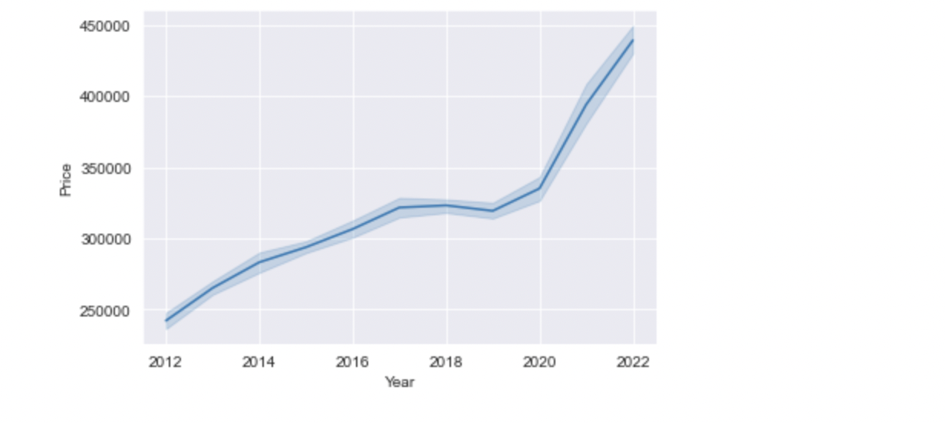

Fig.1

“In September of 2020, Black Knight reported a staggering 14.2% increase in home prices, far above the 25-year average. Driven by low mortgage interest rates and a shortage of inventory, it was the biggest yearly spike seen in more than 15 years.” <https://www.homelight.com/blog/house-price-history/>

**Reasons that drive up the housing prices**

The wide gap between supply and demand is the main reason that housing prices are rising in these two years. Low supply of new inventories and higher consumer demand for new homes created the turbulence in the housing market. General economic conditions and market movements can also impact the housing market.

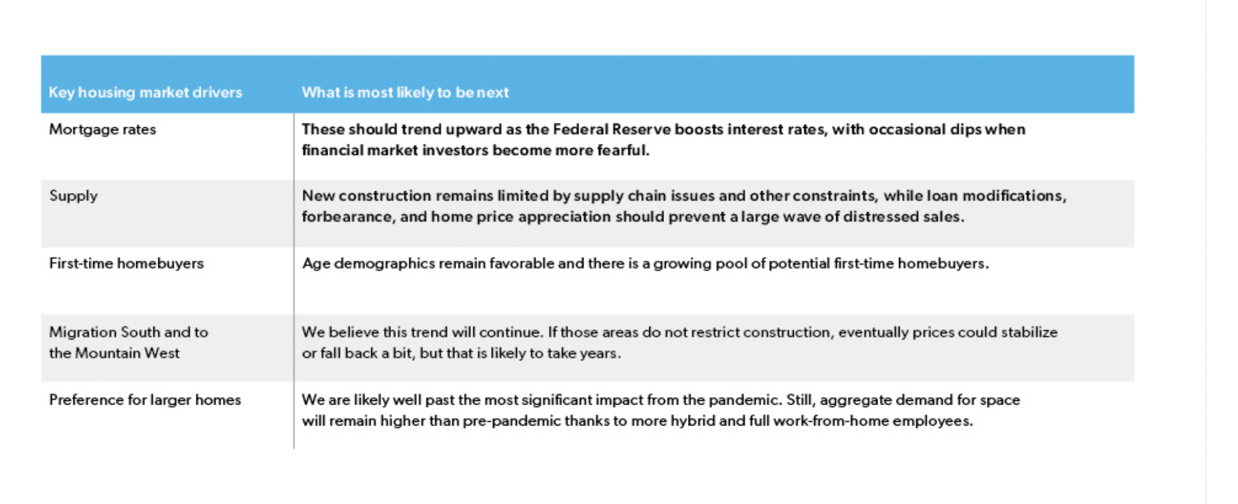

**Demand-side factors related to the pandemic**

* **Increased mobility of consumers**

Increased at-home work and greater mobility altogether are potential pandemic-related demand factors that influence the housing price in the US. At the beginning of the epidemic, there was a significant amount of migration towards suburbs and other less populated areas and created a lot more demand for houses.

<https://www.whitehouse.gov/cea/written-materials/2021/09/09/housing-prices-and-inflation/>

* **Low mortgage rates**

“In an effort to save the economy, policymakers juiced it during the pandemic with unprecedented fiscal and monetary support, including pushing mortgage rates to all-time lows. Those low rates were too good a deal for well-paid professionals who saw their jobs transition to remote to pass up, as they drove up home values in markets like Boise and Austin.”

https://www.goldcoast.financial/news/2022/6/7/the-cooling-housing-market-enters-into-the-great-deceleration

The US fiscal policy during the pandemic created the history-low mortgage rates.”

“Low mortgage rates are making borrowing more affordable (for those with relatively good credit histories), thereby contributing to stronger demand for new homes.”

“The pandemic resulted in the 30-year fixed-rate mortgage dropping from 4.6% at the end of 2018 to a record low of 2.7% at the end of 2020. Comparable declines relative to average rates from the prior three years are rare. That large of a drop in rates has only happened twice before in the past 20 years: in 2003 and after the housing bust in 2009.”

<https://www.whitehouse.gov/cea/written-materials/2021/09/09/housing-prices-and-inflation/>

<https://www.homelight.com/blog/house-price-history/>

<https://www.freddiemac.com/research/forecast/20220720-quarterly-forecast-market-slowdown-will-continue-high-rates-and-prices-exacerbate>

* **Consumer confidence (HPSI)**

In 2020, consumer confidence was also boosted by the pandemic when there was a shortage of reply and growing demand caused by low mortgage rates and consumer mobility.

“In May of 2020, at the height of the first wave of the COVID-19 pandemic, the HPSI fell to 63, its lowest level since November of 2011. Sidelined by business closures, layoffs, and reduced income, consumers weren’t too keen on house-hunting. But the following month, the Index began to climb again, reaching 76.5 in June as consumers recognized that the low supply, growing demand, and escalating house prices had created a strong seller’s market. By October of 2020, the Index had recouped more than 60% of the losses incurred by the pandemic.”

Therefore, consumer confidence (HPSI can also count as an important factor that has driven up the housing prices in these 2 years)

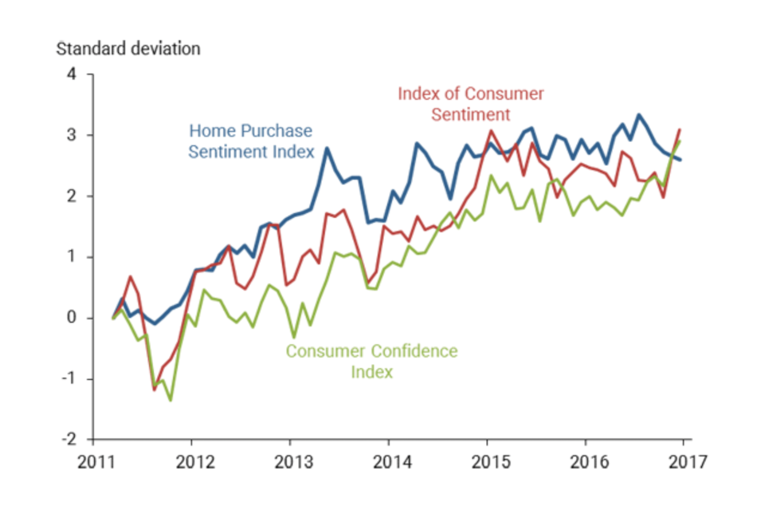

* **Increasing population of homebuying age**

“The pandemic coincided with the five-year window (between 2019 and 2023) when millennials born during the generation's five largest birth years (between 1989 and 1993) hit the peak first-time home buying age of 30. To top it off, a stock market at all-time highs during much of the pandemic had investors flush with cash and ready to park it into real estate.”

<https://www.goldcoast.financial/news/2022/6/7/the-cooling-housing-market-enters-into-the-great-deceleration>

**Supply-side factors related to the pandemic**

* **Housing input prices**

The epidemic also caused more current supply problems, which increased the price of housing inputs. For instance, lumber prices experienced the largest 12-month growth for which data is available, an increase of 114 percent over the 12 months ending in May 2021. The cost of iron and steel had climbed by 73% in June compared to the previous 12 months.

<https://www.whitehouse.gov/cea/written-materials/2021/09/09/housing-prices-and-inflation/>

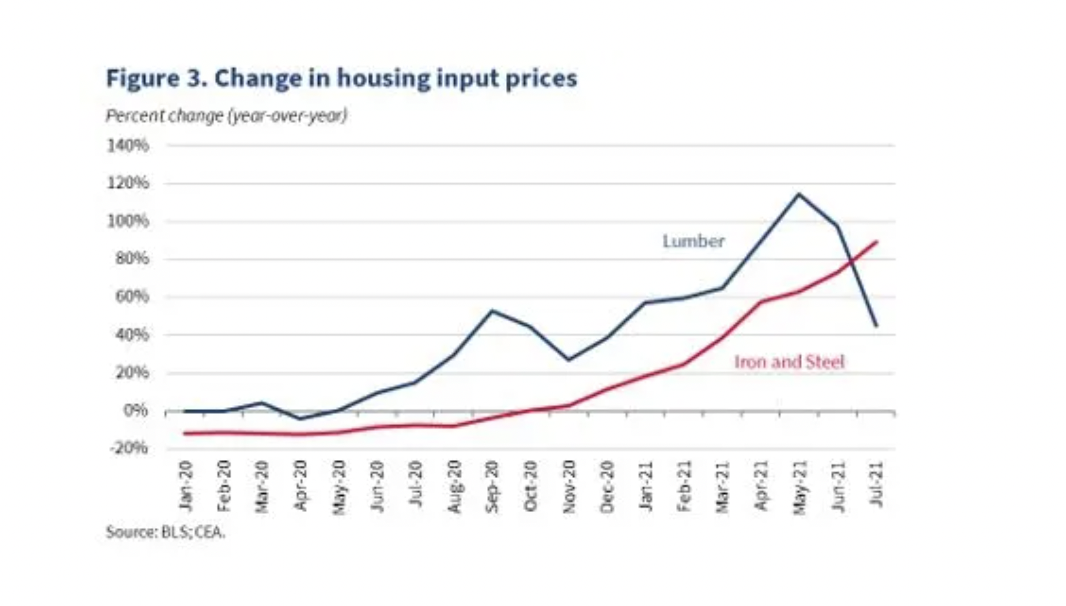

* **Low inventory/Supply Shortage**

According to Redfin, the seasonally-adjusted inventory of homes has declined by over 50 percent since February 2020. Other measures find similarly large declines. For example, the Census Bureau estimates that the inventory of for-sale homes has declined by 37 percent since 2019Q4.

<https://www.redfin.com/news/data-center/>

<https://www.freddiemac.com/research/insight/20220609-what-drove-home-price-growth-and-can-it-continue>

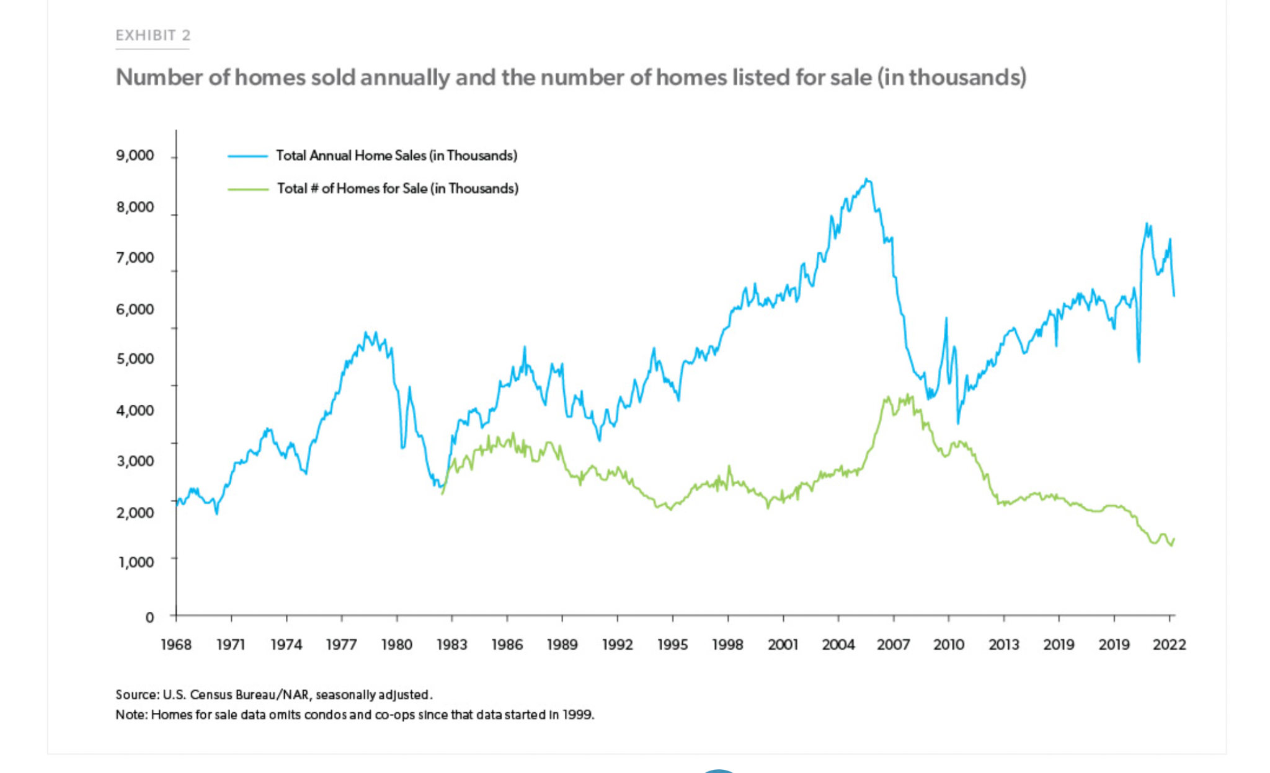

**Macro Economic indicators that influences the housing prices**

1. **Inflation**

Inflation has been rising since 2020.

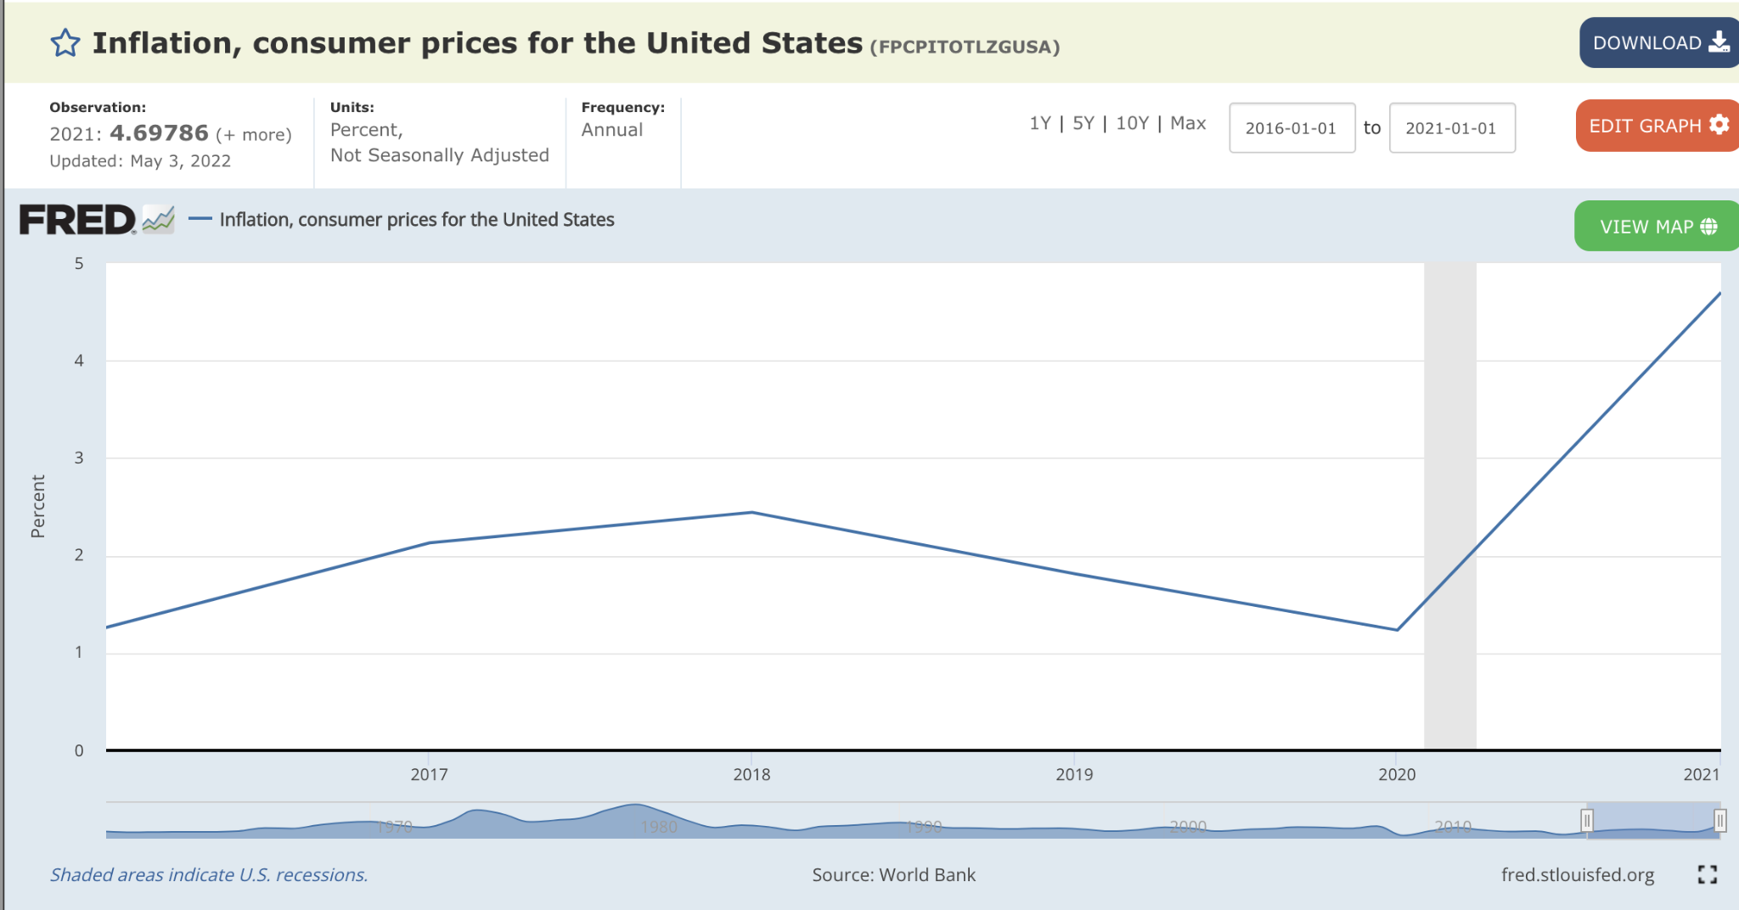

1. **Interest rates**

“When the pandemic struck two years ago, the Federal Reserve used nearly every lever at its disposal to combat the COVID-19 recession. That included cutting its benchmark interest rate to zero. Lower interest rates incentivized businesses to invest and borrow cheap money. It also encouraged buyers—enticed by record low mortgage rates—to jump into the housing market.”

<https://fortune.com/2022/03/23/housing-market-interest-rate-economic-shock/>

**Forcast**

**From April 2022, the housing market is cooling down, however, it will not be a crash according to my research.**

[**https://www.goldcoast.financial/news/2022/6/7/the-cooling-housing-market-enters-into-the-great-deceleration**](https://www.goldcoast.financial/news/2022/6/7/the-cooling-housing-market-enters-into-the-great-deceleration)

The Fed has increased the interest rates in order to help the US economy recover. What the fed do cooled down the housing market, but it won’t cause a crash to the US housing market according to Forbes: “ Despite harsher conditions for buyers and sellers in the coming months, economists are hesitant to suggest that the cooling market could drag down the rest of the economy. That said, if high inflation persists, then rising interest rates could slow down the job market. With worse job prospects and higher mortgage rates, homebuyer interest could collapse to more dangerous levels, driving prices down.

Adds Heym, “The question is how fast can the Fed get inflation down low enough to stop the rising mortgage rates.”

[**https://www.forbes.com/sites/davidwestenhaver/2022/06/16/housing-crash-unlikely-but-experts-say-home-prices-could-collapse-if-rates-and-inflation-keep-soaring/?sh=6488c1a254f4**](https://www.forbes.com/sites/davidwestenhaver/2022/06/16/housing-crash-unlikely-but-experts-say-home-prices-could-collapse-if-rates-and-inflation-keep-soaring/?sh=6488c1a254f4)

**Why is the U.S. housing market finally shifting? There are three main reasons.**

1. Higher interest rates

the Federal Reserve has moved into inflation-fighting mode. The central bank has made it clear: Slowing inflation requires slowing down the red-hot housing market. That's why the Fed has put upward pressure on mortgage rates, which have climbed from 3.11% to 5.25% over the past five months. Rising mortgage rates cause "demand destruction" as would-be homebuyers get priced out.

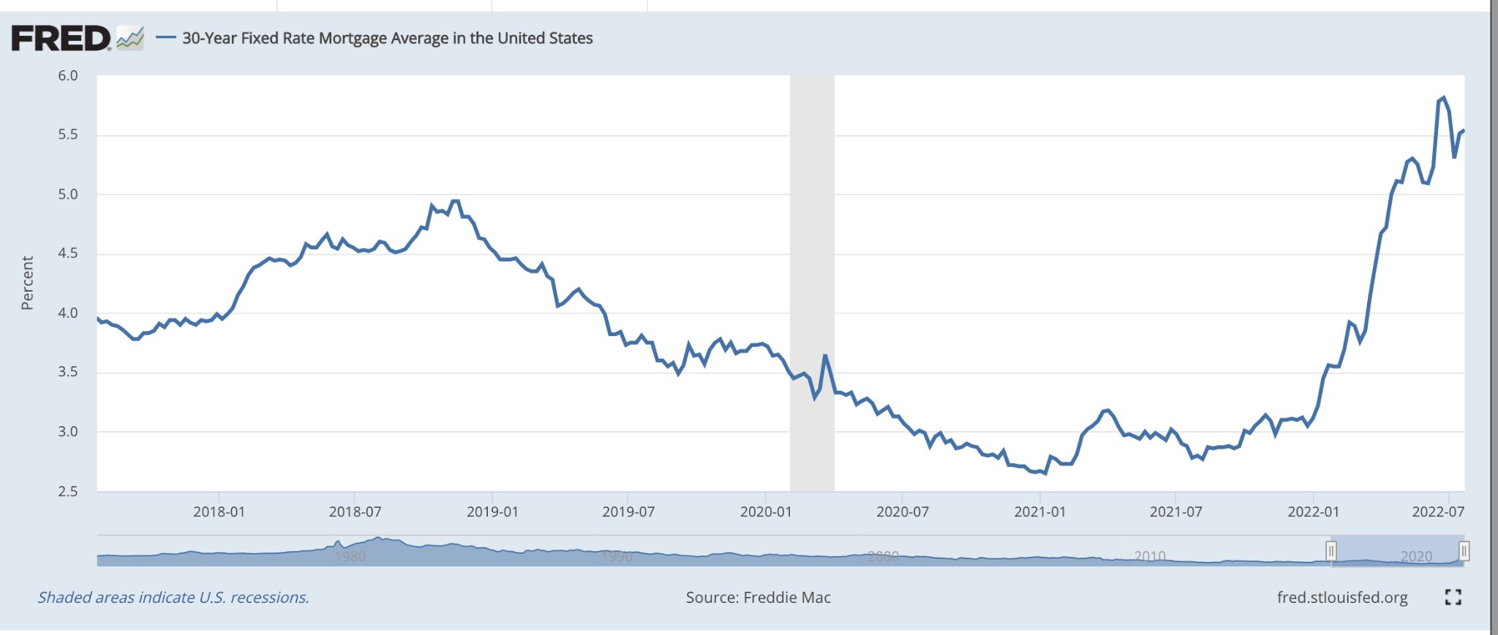

<https://fred.stlouisfed.org/series/MORTGAGE30US>

Second, the overheated 2022 spring market has pushed us over the edge into what housing economists call an overvalued housing market. Last month, Fortune asked Moody's Analytics for its proprietary analysis of U.S. housing markets. The firm's data shows that 96% of regional housing markets are "overvalued" and have home prices that are above what local income levels can support. Simple economics dictates that home price growth (up 19.8% over the past year) can't outpace wage growth (up 4.8% over the past year) by wide margins forever. The housing boom, with help from soaring mortgage rates, may have finally gone too far.

Third, the U.S. economy is losing steam. The Fed isn't just attacking exuberance in the housing market: It's also attempting to slow down the red-hot labor market. Fed chair Jerome Powell has acknowledged that pulling inflation back down will likely require an uptick in unemployment. If the Great Resignation has its own Great Deceleration, it'll undoubtedly trickle over into the housing market. There's something else. If a recession does come, employers could use their increased economic leverage to force staffers back into the office. And if that happens, it could dry up the WFH buying boom.

**Future predictions**

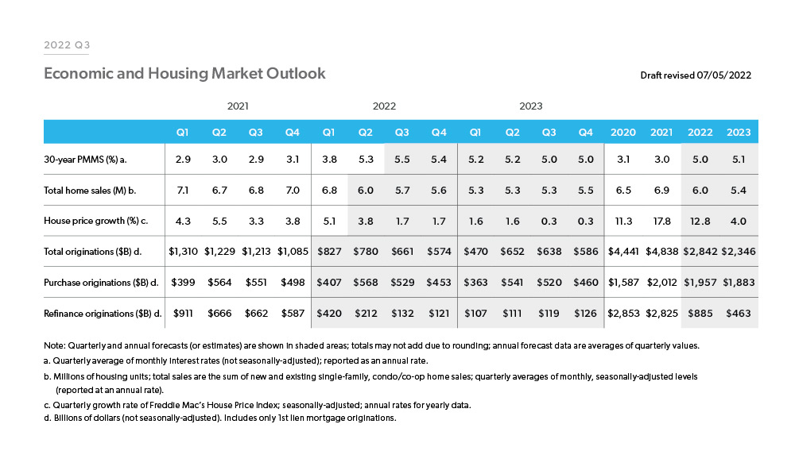

[**https://www.freddiemac.com/research/forecast/20220720-quarterly-forecast-market-slowdown-will-continue-high-rates-and-prices-exacerbate**](https://www.freddiemac.com/research/forecast/20220720-quarterly-forecast-market-slowdown-will-continue-high-rates-and-prices-exacerbate)

“The rise in mortgage rates along with house price appreciation is leading to affordability challenges and causing a slowdown in the housing market. Both existing and new home sales have slowed in the latest surveys. Total home sales are down 17% since the beginning of the year. We expect housing demand to moderate and forecast home sales to slow to 6 million in 2022 and 5.4 million in 2023.

Given the house price growth and home sales expectation, we expect home purchase mortgage originations to be $2.0 trillion in 2022, slowing to $1.9 trillion in 2023. With mortgage rates expected to continue to rise, we forecast refinance activity to slow with refinance originations declining from $2.8 trillion in 2021 to $885 billion in 2022 and $463 billion in 2023. Overall, we forecast total originations to decline from the high of $4.8 trillion in 2021 to $2.8 trillion in 2022 and $2.3 trillion in 2023.”